# 培训

Erp

Wms

Mdm

先集中精力搞WMS和ERP的接口，以及MDM物料主数据批量分发WMS。MDM和CRM的问题讨论出结果再谈，工作推进做些调整。

WMS

ERP

MDM

# 消费方

## Oa

### --ERP

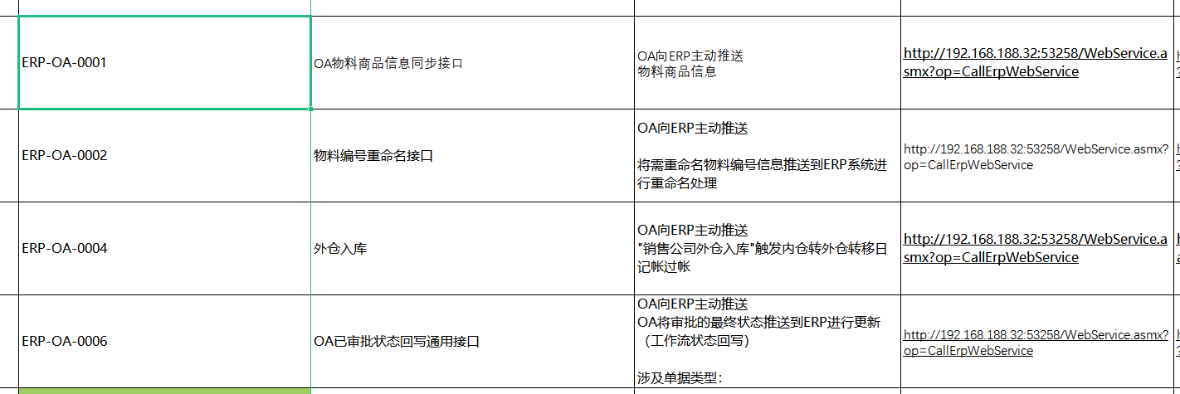

### --mdm

## Crm

### --mdm

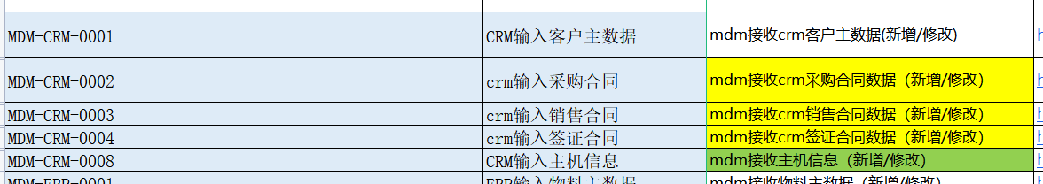

## Erp

## Wms

### -- erp

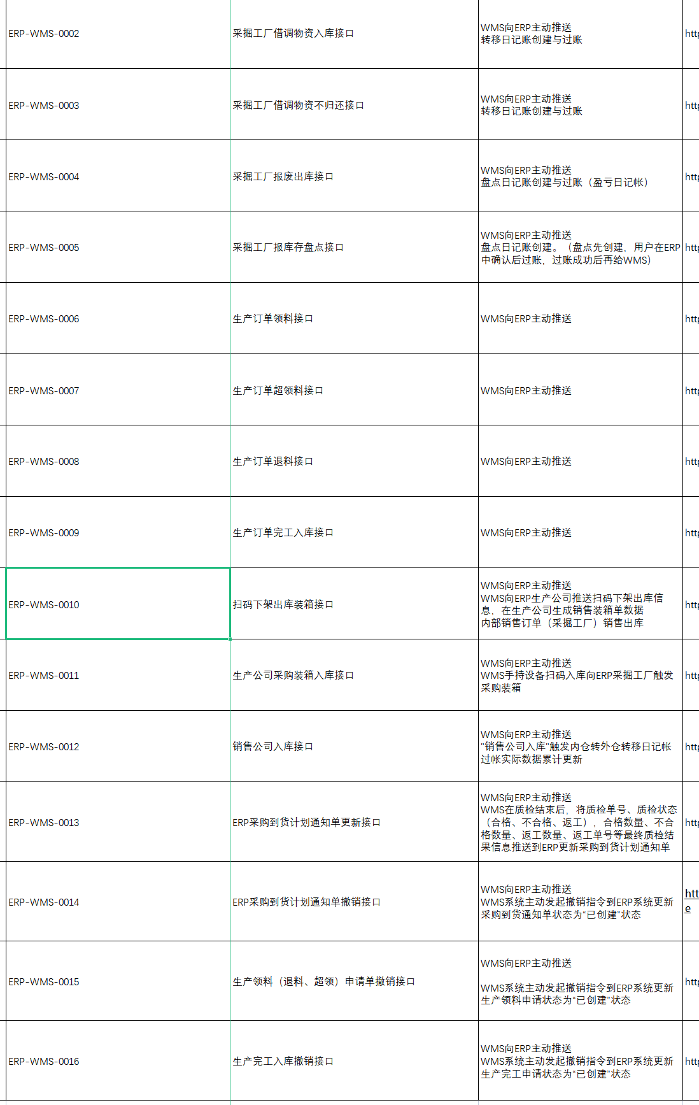

# == 统计方

# -- MDM

<http://192.168.188.191/iuapmdm/cxf/mdmrs/newcenter/newCenterService/insertMd>

Erp



Crm



<http://192.168.188.191/iuapmdm/cxf/mdmrs/newcenter/newCenterService/queryListMdByConditions>

Crm

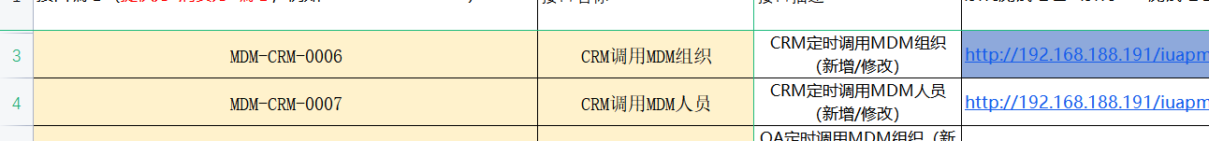

oa

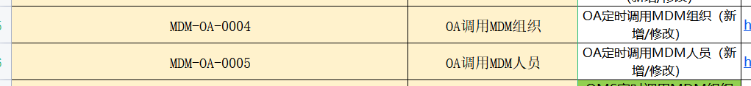

Qms

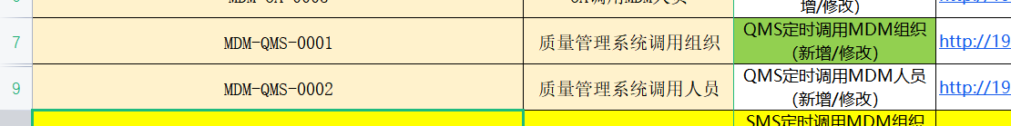

Wms

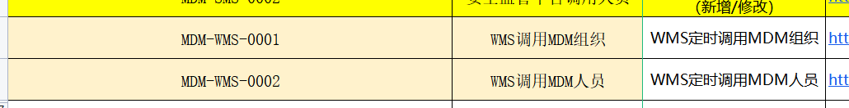

<http://192.168.188.191:9096/basisDoc/byItemId>

oa

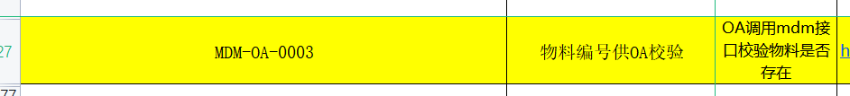

<http://192.168.188.191:9098/oa/checkfromdev>

oa



<http://192.168.188.191:9098/oa/threeCode/researchInsert>

Oa



<http://192.168.188.191:9098/oa/checkfromsales>

Oa



<http://192.168.188.191:9098/oa/threeCode/sellInsert>

[oa](http://192.168.188.191:9098/oa/threeCode/sellInsert)

<http://192.168.188.191:9098/oa/threeCode/itemInsert>

oa



<http://192.168.188.191:9098/oa/threeCode/update>

oa



# --ERP

Oa, wms

**Ws 服务， 只有一个**

Oa



Wms



# -- WMS

<http://192.168.188.195/pwms-app-inf/api/mdm/receive>

mdm

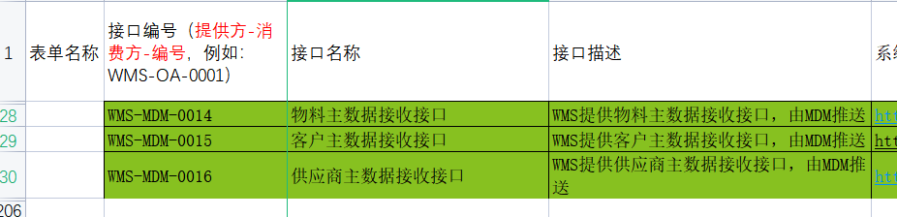

<http://192.168.188.195/pwms-app-inf/api/wms/webservice>

Oa

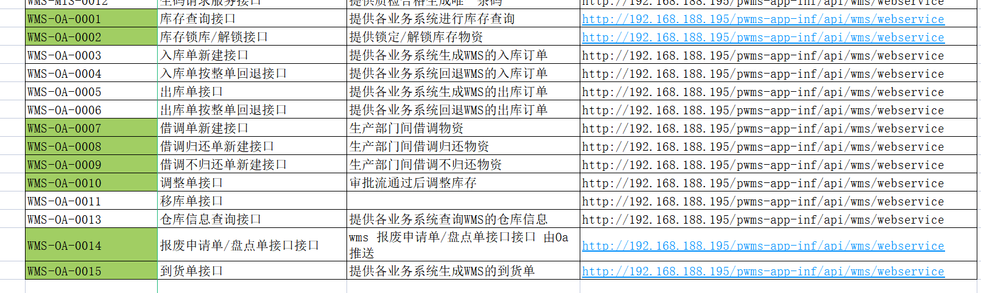

Crm

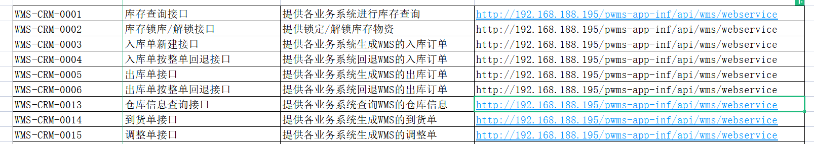

Erp



# QMS

* 不用测试了， 别人测试过了

# OA

http://192.168.188.214:8080/api/ec/dev/auth/applytoken

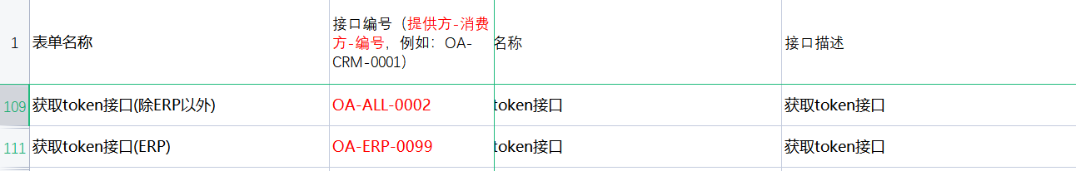

|  |
| --- |
| <http://192.168.188.214:8080/api/ec/dev/auth/regist> |

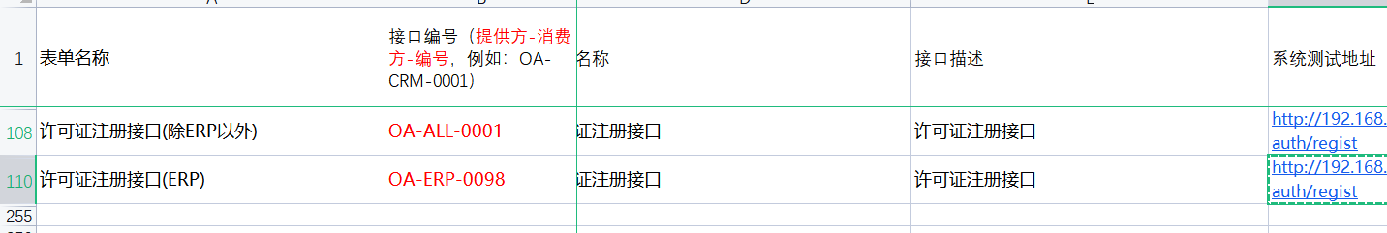

|  |
| --- |
| <http://192.168.188.214:8080/api/workflow/paService/doCreateRequest> |

Crm

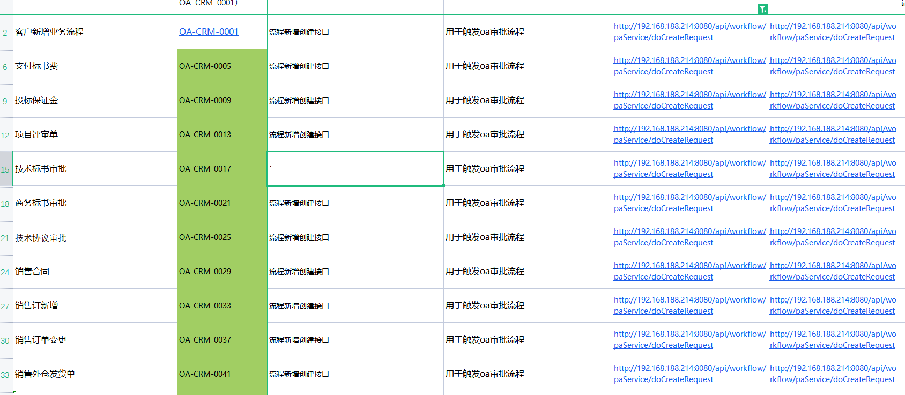

Wms

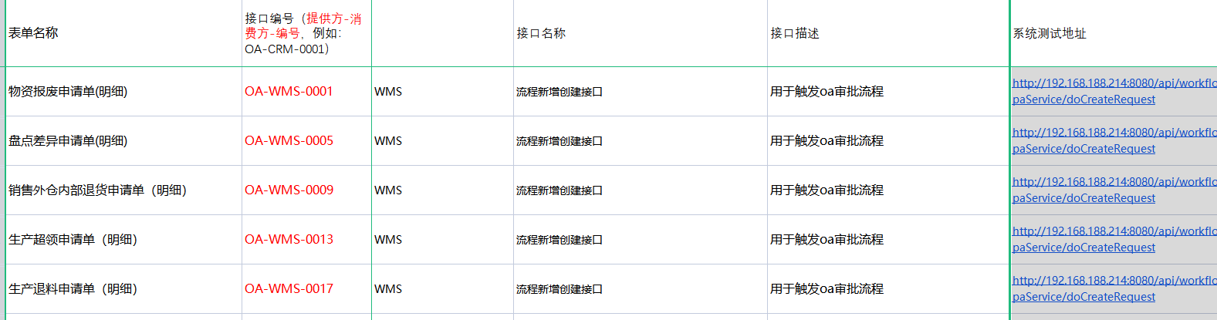

|  |
| --- |
| <http://192.168.188.214:8080/api/workflow/paService/doForceDrawBack> |

crm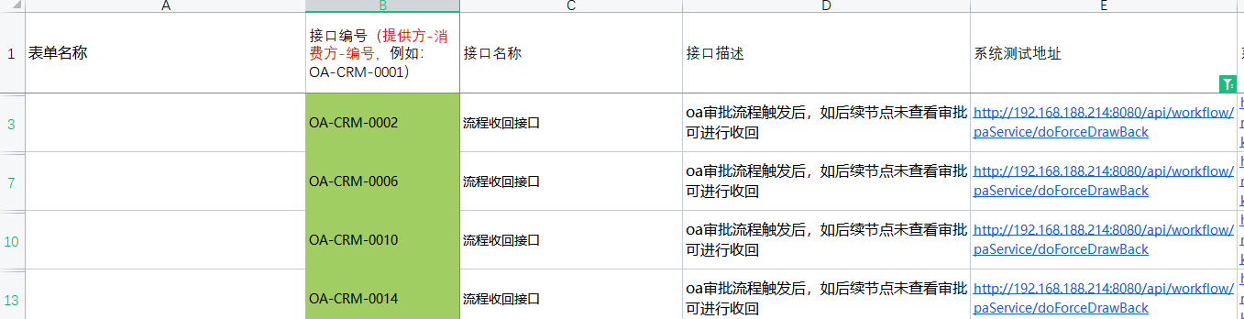

Wms

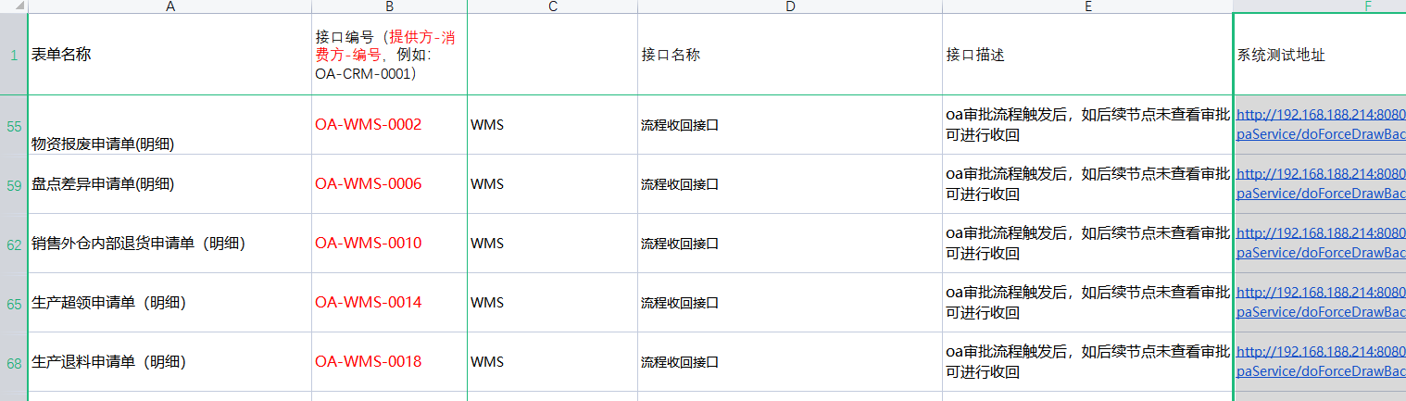

|  |
| --- |
| <http://192.168.188.214:8080/api/workflow/paService/submitRequest> |

crm

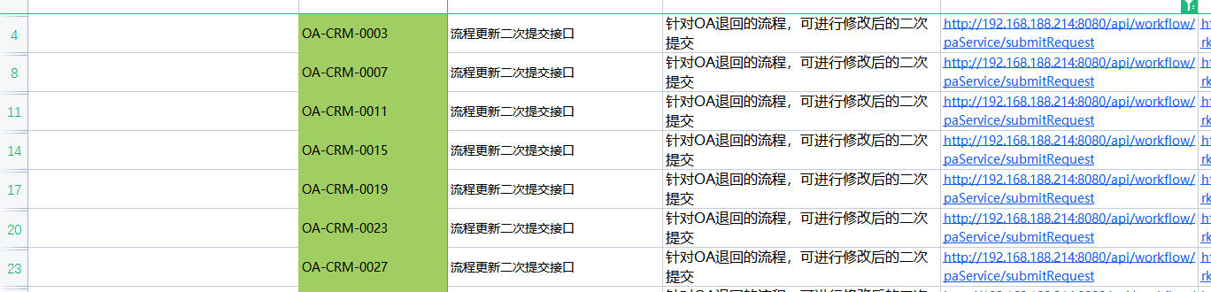

Wms

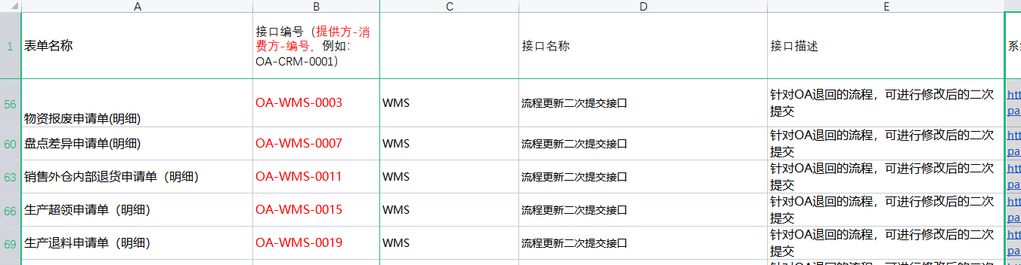

|  |
| --- |
| <http://192.168.188.214:8080/api/workflow/paService/rejectRequest> |

Erp

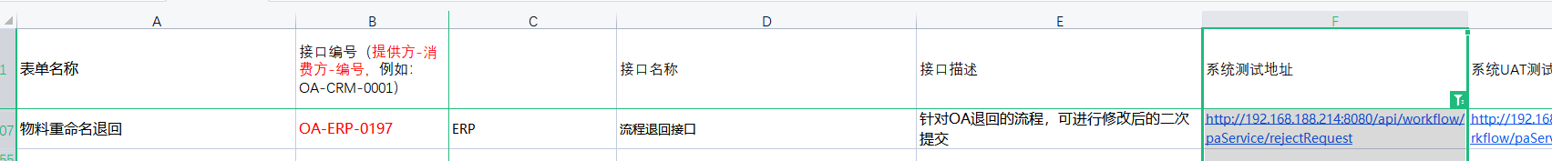

|  |
| --- |
| <http://192.168.188.214:8080/sso/login> |

Crm



# CRM

|  |
| --- |
| <http://172.18.102.210:8888/rest/login> |

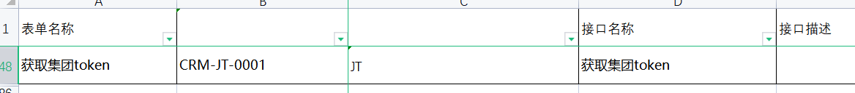

|  |
| --- |
| <http://172.18.102.210:8888/rest/registerContractInfo> |

jt

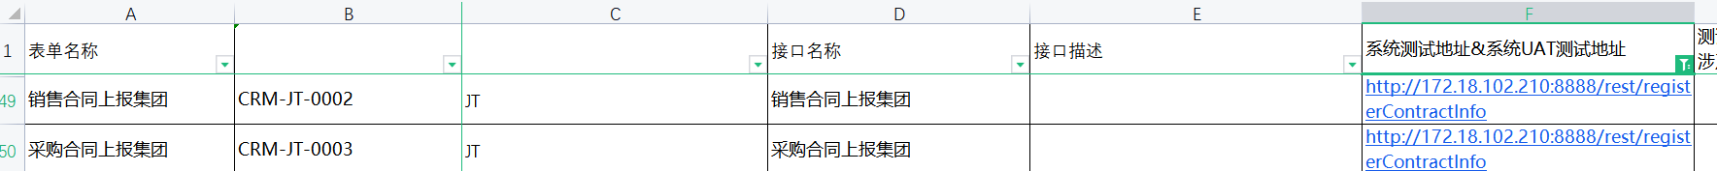

|  |
| --- |
| <http://192.168.188.196:8080/uapws/rest/meike/receive/oaBillStateReceive> |

oa

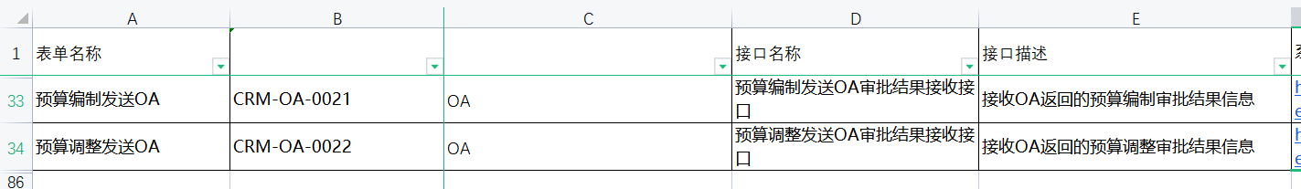

|  |
| --- |
| <http://192.168.188.206/uapws/rest/meike/maindata/pullMaterial> |

mdm



|  |
| --- |
| <http://192.168.188.206/uapws/rest/meike/maindata/pullSupplier> |

mdm

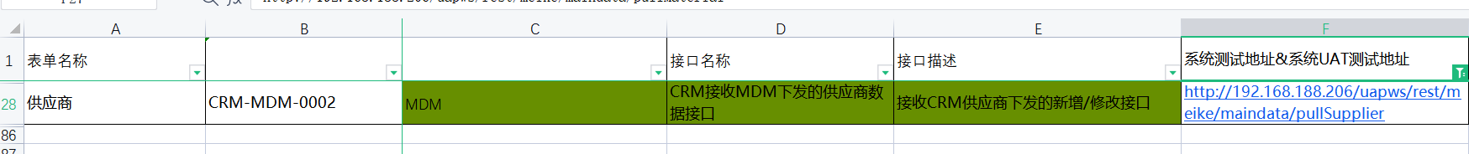

|  |
| --- |
| <http://192.168.188.206/uapws/rest/meike/receive/billReceive> |

wms

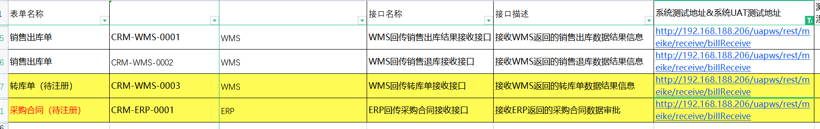

|  |
| --- |
| <http://192.168.188.206/uapws/rest/meike/receive/oaBillStateReceive> |

oa

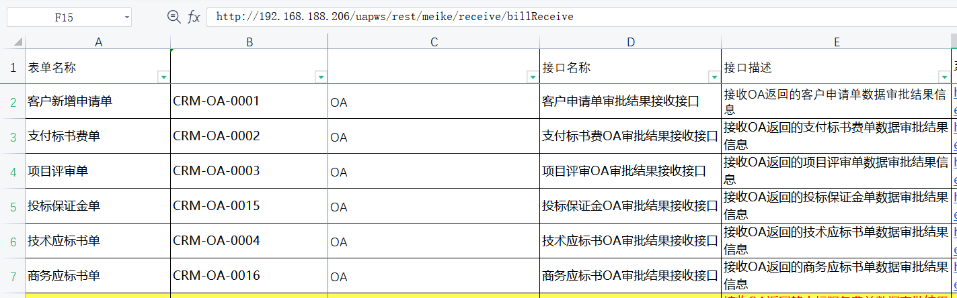

|  |
| --- |
| <http://192.168.188.206:80/uapws/rest/meike/receive/oaBillStateReceive> |

Oa

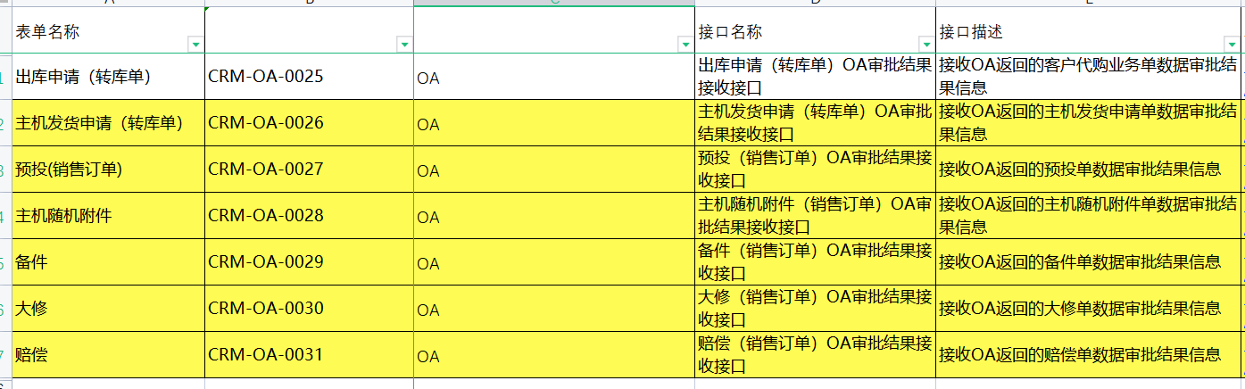

|  |
| --- |
| <http://192.168.188.206:80/uapws/rest/meike/salesOrder/configChange> |

Erp



|  |
| --- |
| <http://192.168.188.206:80/uapws/rest/meike/salesOrder/receive/execreport> |

Erp

